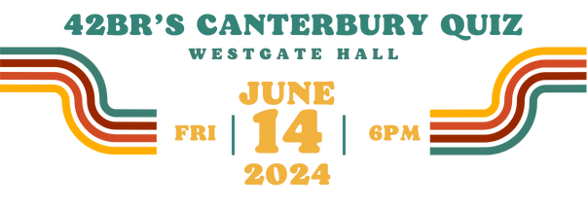

42BR's Family Group invite you to join us for an evening of quizzing
Friday 14th June 2024
6pm arrival for a 6:30 start until 9pm
Westgate Hall, Canterbury CT1 2BT

Tickets: £20 per person or £100 for a team of 6.
Name of person making booking:

Company:

Email address:

Number of individual tickets:

Number of team bookings (6 people per team):

Total amount due:

Bank Name: C. Hoare & Co Bank
Account Name: 42 Bedford Row No. 2 Account
Account Number: 53500930
Sort Code: 15-99-00

Please use reference QN-42BR-Company Name when making payment.
Return booking form to events@42br.com.




